Sample Materials
Words
- Name all the possible uses for a Blazer that you can think of. Keep in mind that a single object may have many possible uses.

- Name all the possible uses for a Knife that you can think of. Keep in mind that a single object may have many possible uses.

- Name all the possible uses for a Lock that you can think of. Keep in mind that a single object may have many possible uses.

- Name all the possible uses for a Pickaxe that you can think of. Keep in mind that a single object may have many possible uses.

- Name all the possible uses for a Screw that you can think of. Keep in mind that a single object may have many possible uses.

Pictures

- Name all the possible uses for a Pictured Object that you can think of. Keep in mind that a single object may have many possible uses.
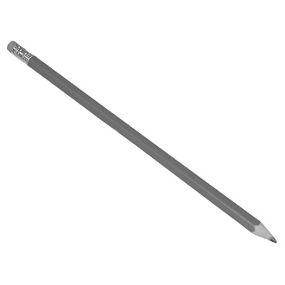
- Name all the possible uses for a Pictured Object that you can think of. Keep in mind that a single object may have many possible uses.
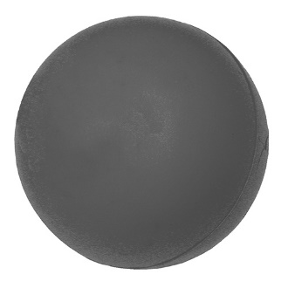
- Name all the possible uses for a Pictured Object that you can think of. Keep in mind that a single object may have many possible uses.
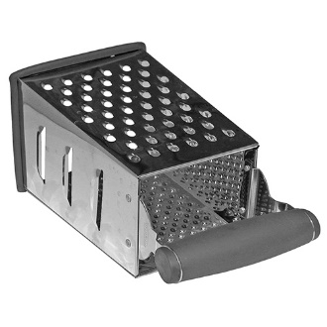
- Name all the possible uses for a Pictured Object that you can think of. Keep in mind that a single object may have many possible uses.
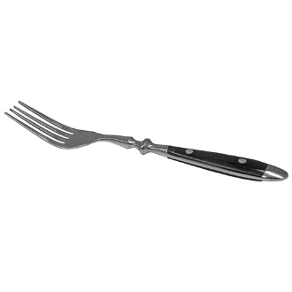

- Name all the possible uses for a Pictured Object that you can think of. Keep in mind that a single object may have many possible uses.
